**PET STORE**

**1. ABSTRACT**

In this project “**Pet Store**” website mainly used to show the pet animals and birds collection. Much variety of pets such as dog, cat, fish, parrot, lovebirds are presented in this webpage collection. Pet category, price, photo, maintenance details are clearly shown in the site. Based on the user customization they can view and search the crystal pet’s data.

The guidance to manage each category pets also mentioned in the web page. The food activities for every pet can provide in this site. In this site the user can also able to view availability of pet clinic. The authorized administrator controls the entire system. They have the privileges to maintain the application

**2. SYSTEM REQUIREMENT**

**2.1 HARDWARE SPECIFICATION**

CPU Type : Intel(R) Core i7

Clock Speed : 2.40 GHz

RAM : 2GB

Keyboard : Multimedia

Mouse : OPTICAL Mouse

Hard Disk : 256GB

**2.2 SOFTWARE SPECIFICATION**

Operating System : Mac OS Big Sur

WAMP : Web Application Server

PHP : Server Side Scripting Language

MYSQL : Database

HTML : Hyper Text Mark-up Language

**2.3 SOFTWARE DESCRIPTION**

**About PHP and MySQL**

PHP is the Web development language.

PHP stands for PHP: Hypertext Pre-processors.

 PHP is a Server-side scripting language, which can be embedded in HTML or used as a standalone binary.

Rasmus Lerdorf – a software engineer, Apache team member is the creator and original driving force behind PHP.

Strictly speaking, PHP has little to do with layout, events, on the fly DOM manipulation, or really anything about what a Web page looks and sounds like. In fact, most of what PHP does is invisible to the end user. Someone looking at a PHP page will not necessarily be able to tell that it was not written purely in HTML, because the result of PHP isHTML.

The PHP pre-processor has two modes of operation, copy mode and interpret mode. It takes a PHP document file as input and produces an XHTML document file.

PHP is usually purely interpreted. The syntax and semantics of PHP are closely related to the syntax of JavaScript and Perl. It uses dynamic typing. PHP has an extensive library of functions, making it a flexible and powerful tool for server-side software development.

MySQL (pronounced My Ess Q El) is an open source. MySQL is a free, highly efficient, widely used database system that implements SQL. There are a plethora of tools, both in MySQL itself and available from third parties, to make this job even easier. MySQL isn’t a database until you give it some structure and form.

PHP is an open-source language, and PHP.net is its control centre, with extensive reference material about the language and tips sent in by users across the globe. PHP.net has exceptional, deep information about the language, but it can be a little cryptic for the newcomer.

Speed: It is relative fast since it uses much system resource.

Easy to use: It uses C like syntax, so for those who are familiar with C, it's very easy for them to pick up and it is very easy to create website scripts.

Stable: Since it is maintained by many developers, so when bugs are found, it can be quickly fixed.

Powerful library support: You can easily find functional modules you need such as PDF, Graph etc.

Built-in database connection modules: You can connect to database easily using PHP, since many websites are data/content driven, so we will use database frequently, this will largely reduce the development time of web apps.

Can be run on many platforms, including Windows, Linux and Mac, it's easy for users to find hosting service providers.

**About Wamp Server**

Stands for "Windows, Apache, MySQL, and PHP." WAMP is a variation of [LAMP](https://techterms.com/definition/lamp) for Windows systems and is often installed as a [software](https://techterms.com/definition/software) bundle (Apache, MySQL, and PHP). It is often used for [web development](https://techterms.com/definition/web_development) and internal testing, but may also be used to serve live websites.

The most important part of the WAMP package is [Apache](https://techterms.com/definition/apache) (or "Apache HTTP Server") which is used run the [web server](https://techterms.com/definition/web_server) within Windows. By running a local Apache web server on a Windows machine, a web developer can test [webpages](https://techterms.com/definition/webpage) in a [web browser](https://techterms.com/definition/web_browser) without publishing them live on the Internet.

WAMP also includes [MySQL](https://techterms.com/definition/mysql) and [PHP](https://techterms.com/definition/php), which are two of the most common technologies used for creating [dynamic websites](https://techterms.com/definition/dynamicwebsite). MySQL is a high-speed database, while PHP is a scripting language that can be used to access data from the database. By installing these two components locally, a developer can build and test a dynamic website before publishing it to a public web server.

**3. SYSTEM ANALYSIS**

**3.1 EXISTING SYSTEM**

Existing system refers to the system that is being followed till now. The existing system requires more computational time, more manual calculations, and the complexity involved in Selection of features is high. The other disadvantages are lack of security of data, Deficiency of Data accuracy, Time consuming etc. To avoid all these limitations and make the working more accurately the system needs to be computerized.    Here in the Electronic bus ticketing, a detailed study of existing system is carried along with all the steps in system analysis.

**Draw backs of existing system.**

Here in Pet shop management system, a detailed study of existing system is carried along with all the steps in system analysis. An idea for creating a better project was carried and the next steps were followed.

* Lack of security of data.
* More man power.
* Time consuming.
* Consumes large volume of pare work.

**3.2 PROPOSED SYSTEM**

The aim of proposed system is to develop a system of improved facilities. The proposed system can overcome all the limitations of the existing system. The system provides proper security and reduces the manual work. The existing system has several disadvantages and many more difficulties to work well. The proposed system tries to eliminate or reduce these difficulties up to some extent. The proposed system will help the user to reduce the workload and mental conflict. The proposed system helps the user to work user friendly and he can easily do his jobs without time lagging.

**Advantages of Proposed System**

The system is very simple in design and to implement. The system requires very low system resources and the system will work in almost all configurations. It has got following features

* Ensure data accuracy.
* Minimize manual data entry.
* Minimum time needed for the various processing
* Greater efficiency
* Better Service
* Minimum time required
* This would help the corporation prepare and organize its schedules their requirement

**4. SYSTEM DESIGN**

**4.1 DATA FLOW DIAGRAM**

**Level 0**

Admin

User

**Level 1**

Admin

User

Upload data

Shopping

View data

**4.2 TABLE DESIGN**

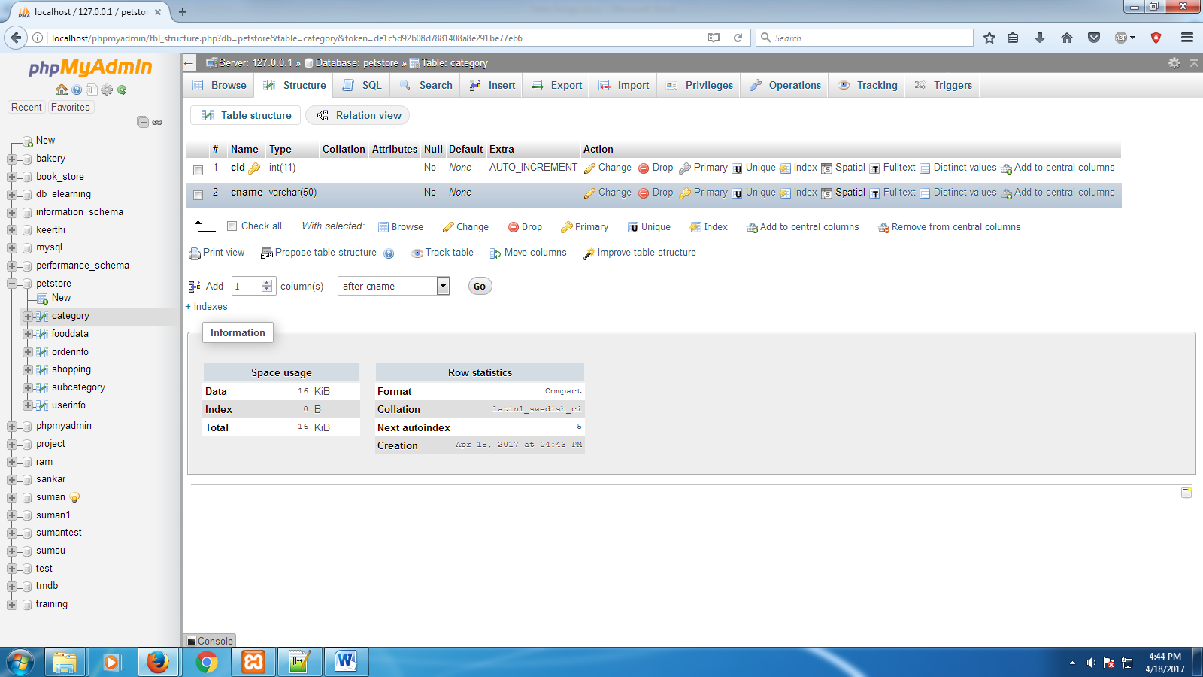**Category:**

**Subcategory:**

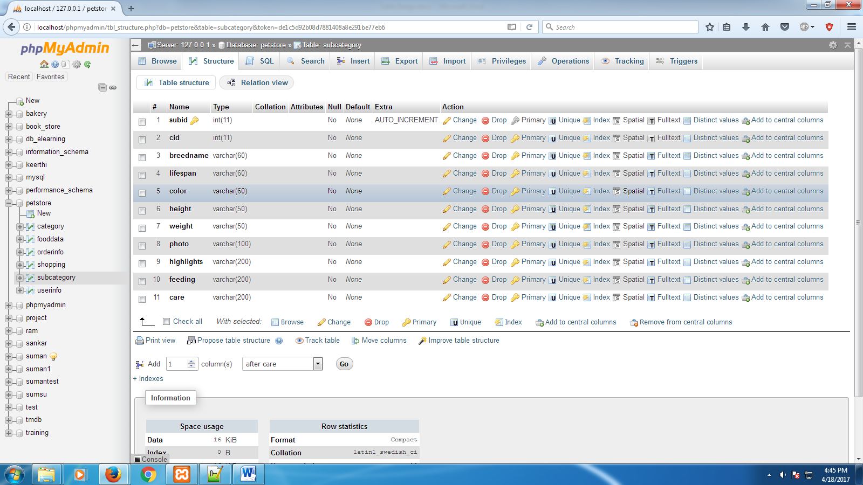

**Food Data:**

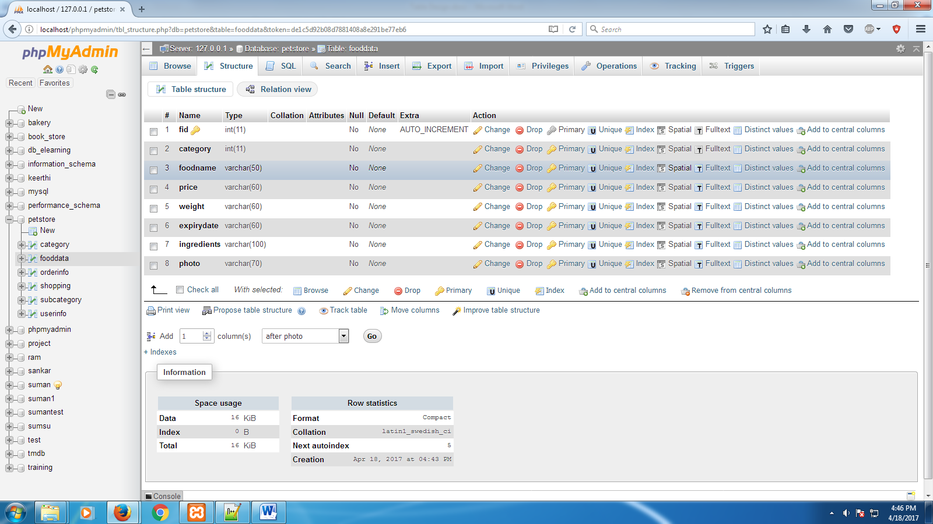

**User info**

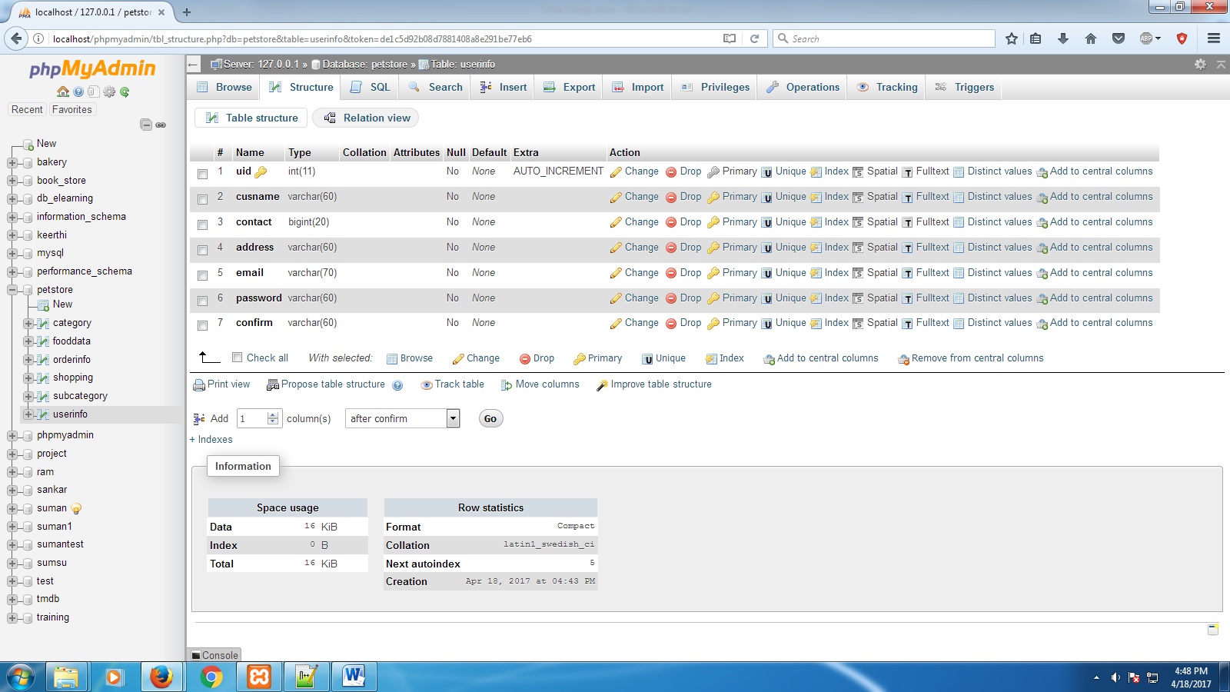

**Order info:**

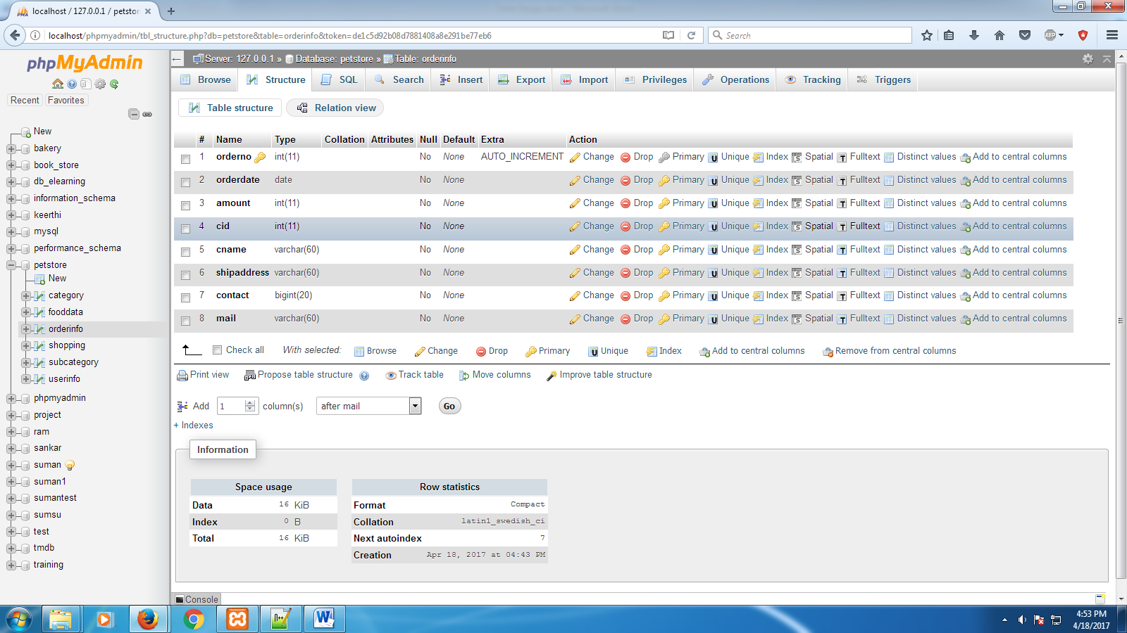

**Shopping:**

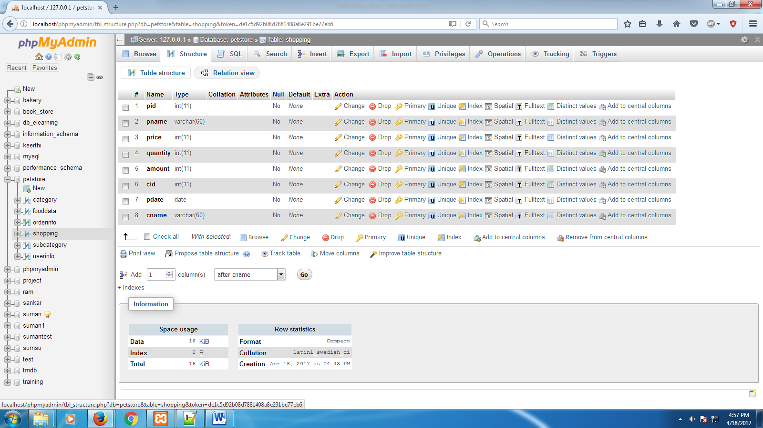

**5. MODULE DESCRIPTION**

* **Category**

In this module the user views pet animals details based on the category. Many categories of pets are there such as dog, cat, parrot, dove etc... In each category many varieties of pets are there. User can able to view information about all pets in each variety. This categorization of the pets helps the user to pick their favorite pets easily.

* **Searching**

In this module the user able to search the pets’ information based on the category and sub category. In breed searching shows that what kind of dog or cat would be best for user lifestyle. A particular pet name, price, maintenance details are showed in each searching. The pet’s picture and their activities also showed detail.

* **Food**

In this module the user can able to view the food habits for pets in each category. The food habits for each pet is so different so the pet owner can easily find the food for their pet based on the category and maintain their pet healthy. There are so many food items such as canned food, dry food etc. the user can find what food is suitable for their pets.

* **Pet clinic**

In this module there are many pet clinic to maintain their pets healthy, the user can find the availability of pet clinic and also some mention some of the health tips such as physical examination, routine health check-up preventive measures to grown up their pets healthy.

* **Admin**

Using their authentication information the admin entered into the system and accesses the data. An authorized admin control the entire web page activity. They only decide to which of the items are shown in the website. A new pet detail, offer details and everything only uploaded by the administrator. They update the webpage concurrently.

**6. TESTING**

**6.1 UNIT TESTING**

Testing is a process of executing a program with the interest of finding an error. A good test is one that has high probability of finding the yet undiscovered error. Testing should systematically uncover different classes of errors in a minimum amount of time with a minimum amount of efforts. Two classes of inputs are provided to test the process

1. A software configuration that includes a software requirement specification, a design specification and source code.
2. A software configuration that includes a test plan and procedure, any testing tool and test cases and their expected results.

Unit test comprises of a set tests performed by an individual program

Prior to the integration of the unit into large system. A program unit is usually the smallest free functioning part of the whole system. Module unit testing should be as exhaustive as possible to ensure that each representation handled by each module has been tested. All the units that makeup the system must be tested independently to ensure that they work as required.

**6.2 INTEGRATION TESTING**

Integration testing is a system technique for constructing the Program structure while at the same time conducting tests to uncover errors associated with interfacing. The objective is to take unit tested modules and build a program structure that has been dictated by design. Bottom-up integration is the traditional strategy used to integrate the components of a software system into functioning whole.

Bottom-up integration consists of unit test followed by testing of the entire system. A sub-system consists of several modules that communicated with other defined interface.

The system was done the integration testing. All the modules were tested for their compatibility with other modules .They test was almost successful. All the modules coexisted very well, with almost no bugs. All the modules were encapsulated very well so as to not hamper the execution of other modules.

**7. CONCLUSION**

The Pet Store project anticipates expanding to keep up with the ever growing Demand. Marketing is changing as this new source of product has become integrated into society. The users will consume less amount of time through shopping online rather than visiting and shop directly. The user can buy items sitting anywhere, any time around the world. It’s a 365/24 service. The transactions will be taken care by the system all the time.

The project Pet Store is completed, satisfying the required design specifications. The system provides a user-friendly interface. The software is developed with modular approach. All modules in the system have been tested with valid data and invalid data and everything work successfully. Thus the system has fulfilled all the objectives identified and is able to replace the existing system.

The constraints are met and overcome successfully. The system is designed as like it was decided in the design phase. This software has a user-friendly screen that enables the user to use without any inconvenience. This would help the corporation prepare and organize its schedules more efficiently on the basis of traffic demand. Besides, it would provide data on concessions given to various sections.

**8. FUTURE ENHANCEMENT**

Pet store is a web based project which is made for remote shopping or shopping through internet. As the technology is being advanced the way of life is changing accordance. Now a day we can place the order for anything from our home. There is no need to go the shop of the things we want. Now we can think how the days have been changed with time. People had to stand in rows to wait there terms to buy a particular thing from a popular shop. But what is happening now a day; we can extremely surprise that those things can be available on the door-step in few hours.

Pet Store is one of the important facility provided in online shopping, this lets customer to browse different Pets and Foods and once they select an item to purchase they can place the item in shopping cart, and continue browsing till the final selection. Customers can even remove the items from shopping cart that were selected earlier before they place the final order. It reminds us of shopping basket that we carry in our Pet store

Although the online buyer cannot return an item as quickly in some situations as the buyer who can walk in and out of a Wal-Mart or Sears when the parking lot isn't crowded or there is no line at the returns desk, there are many other reasons to buy online.

**9. BIBILIOGRAPHY**

PHP book by Vasvani (TMH publications)

Beginning PHP5 by WROX

Head First PHP & MYSQL by Lynn Beighley and Michael Morrison (O’Reilly)

www.w3schools.com

www.tutorialspoint.com

www.mytoptutorials.com

**10. APPENDIX**

**10.1 SCREEN SHOTS**

**Home page**

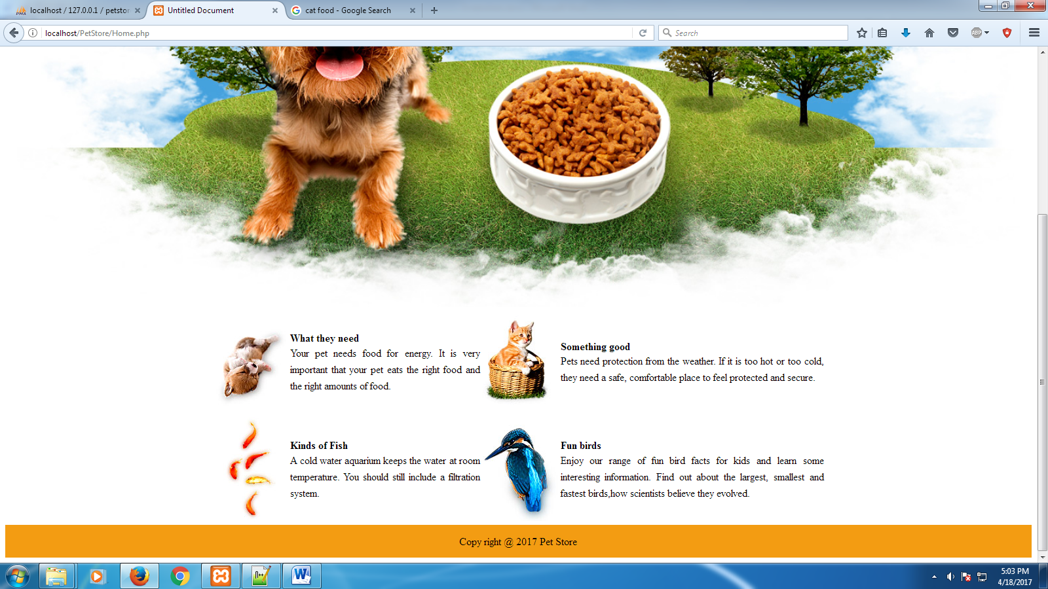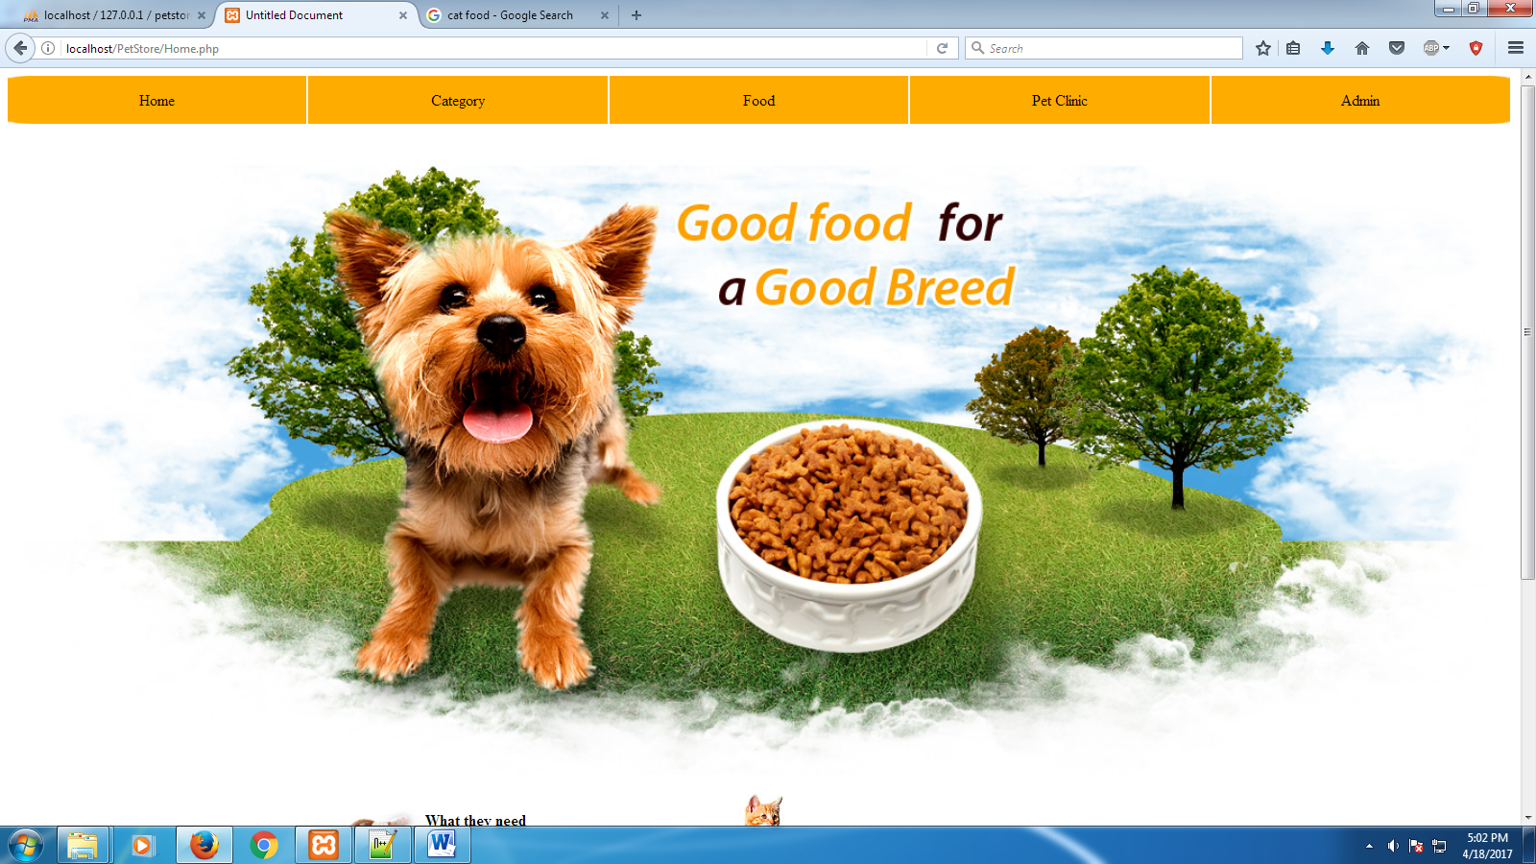

**Category**

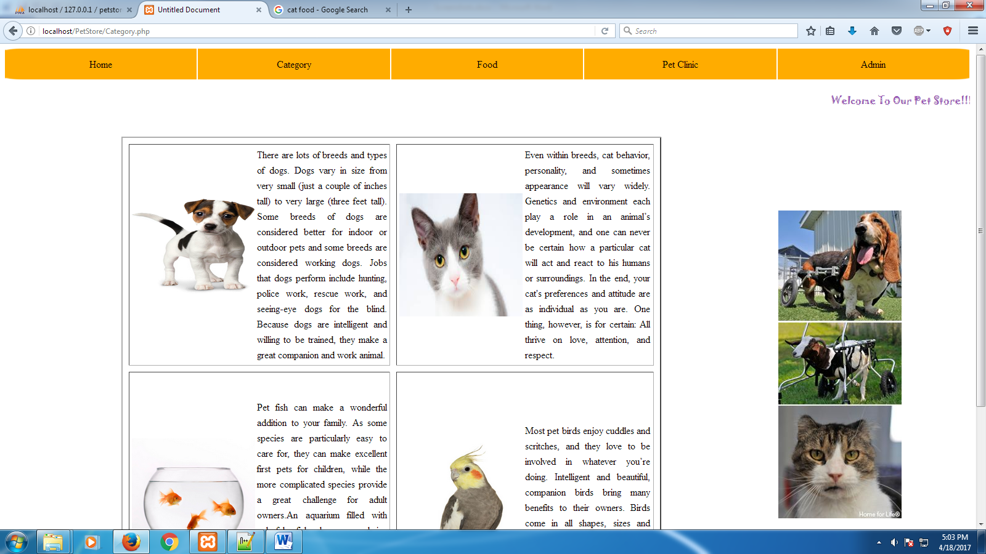

**Admin login**

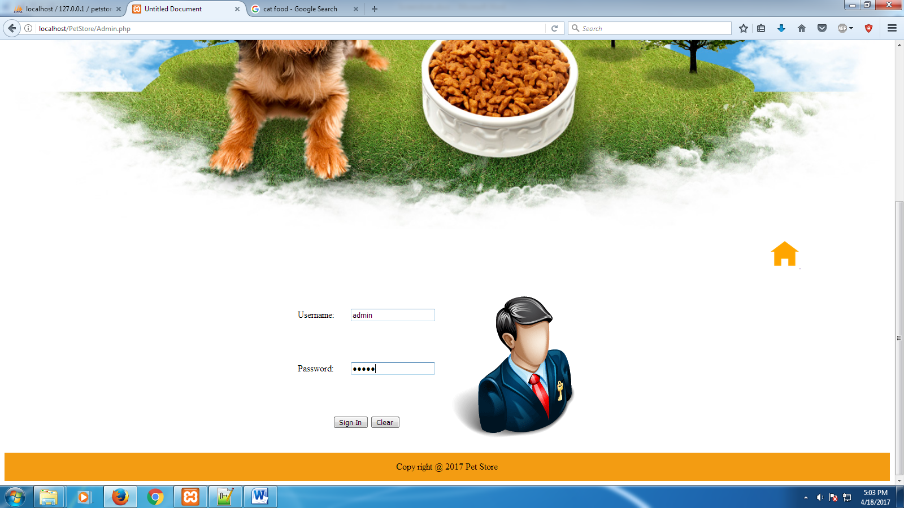

**Breed information**

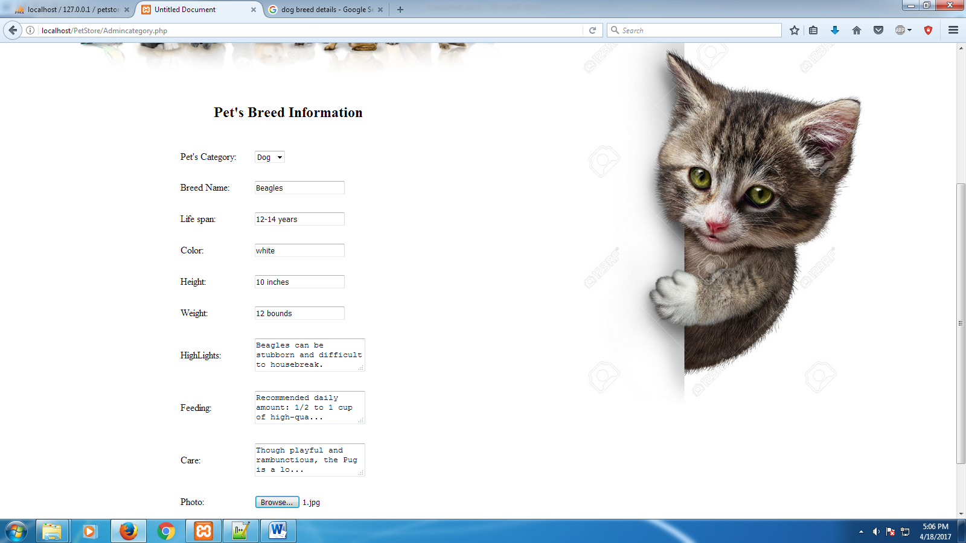

**Food information**

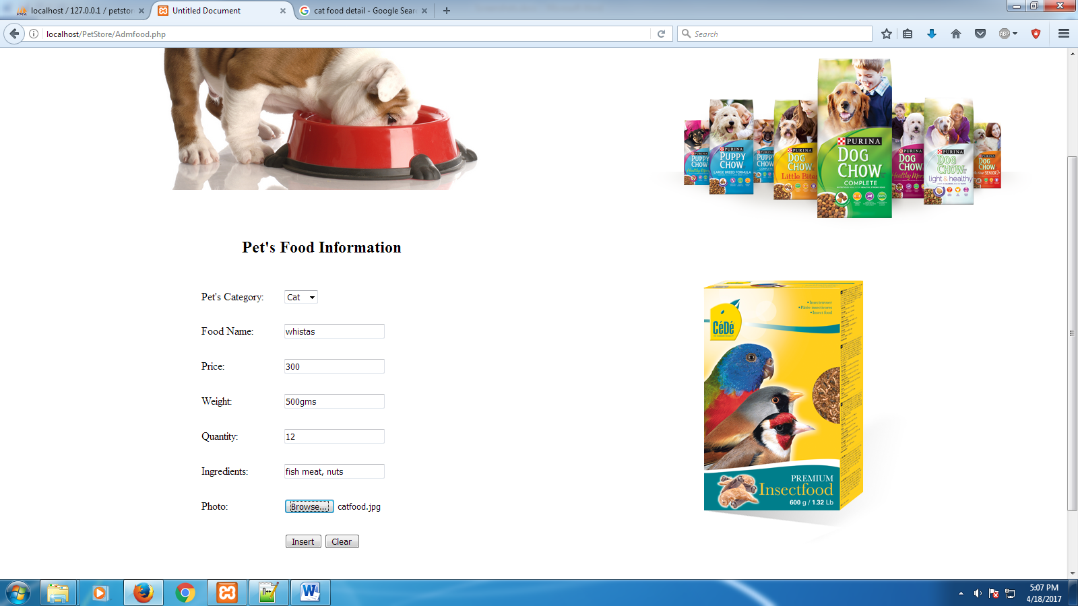

**Order details**

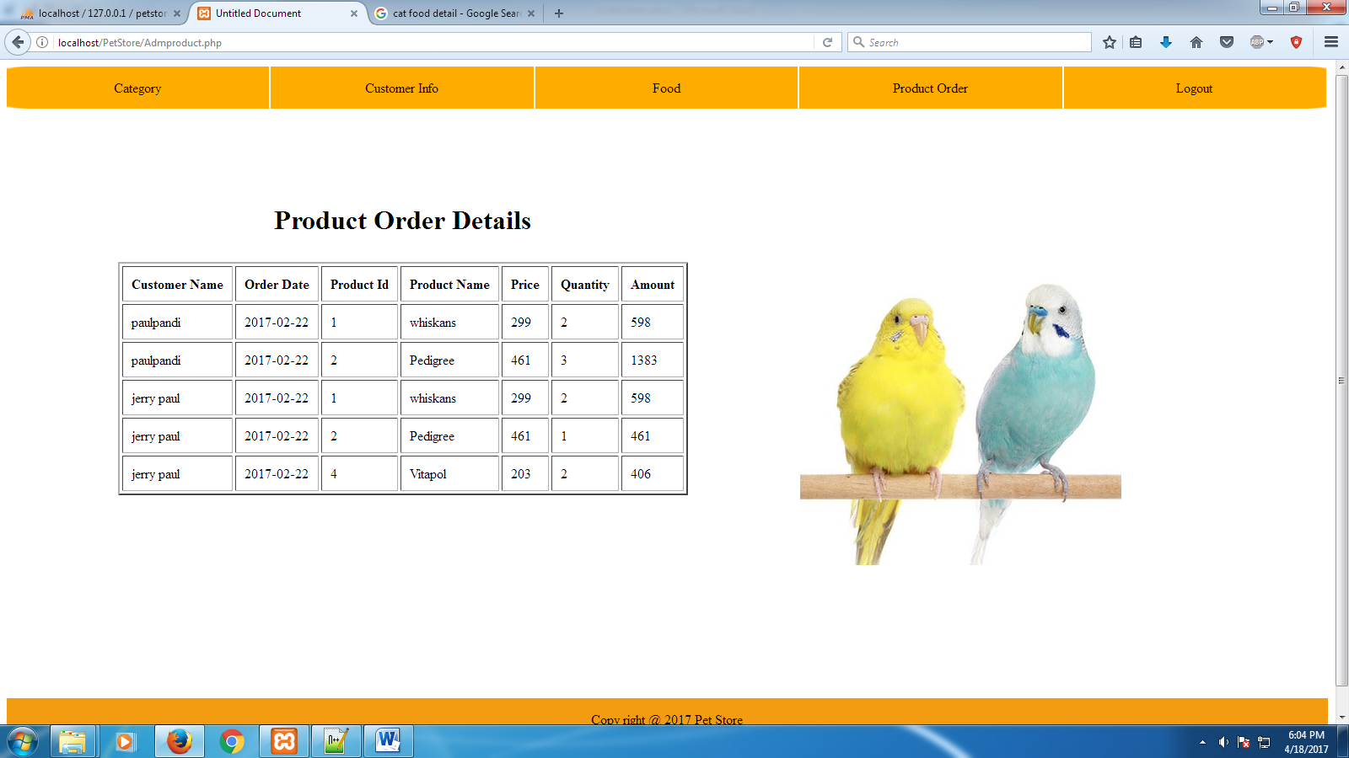

**User login**

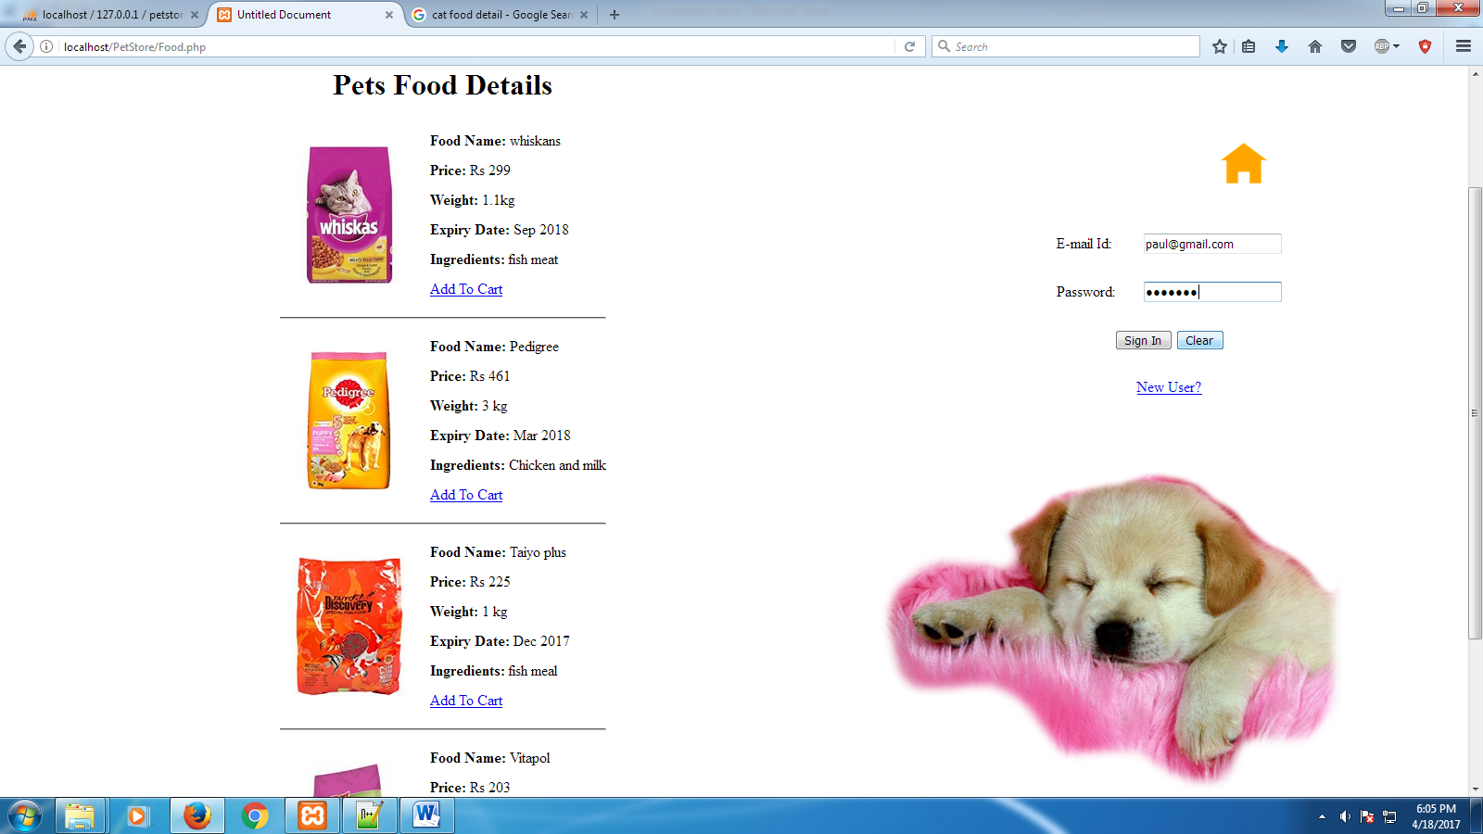

**User profile**

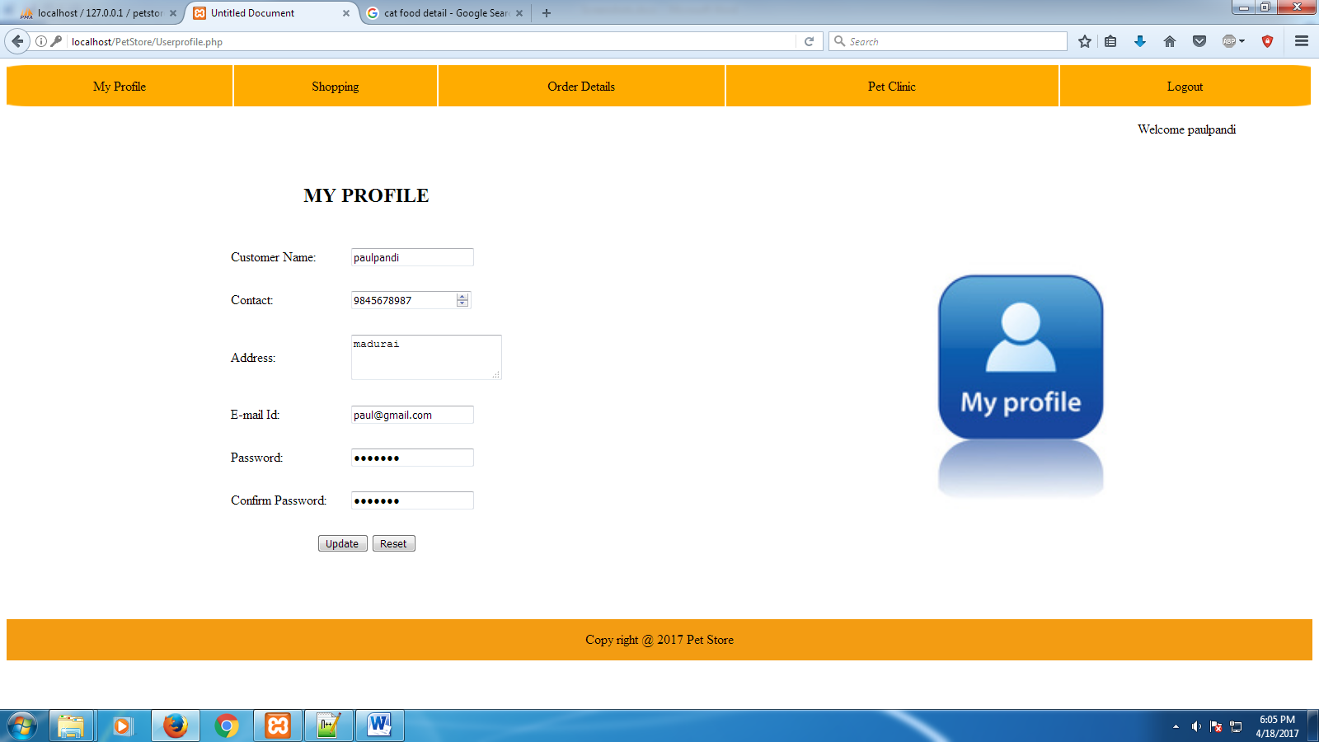

**Shopping**

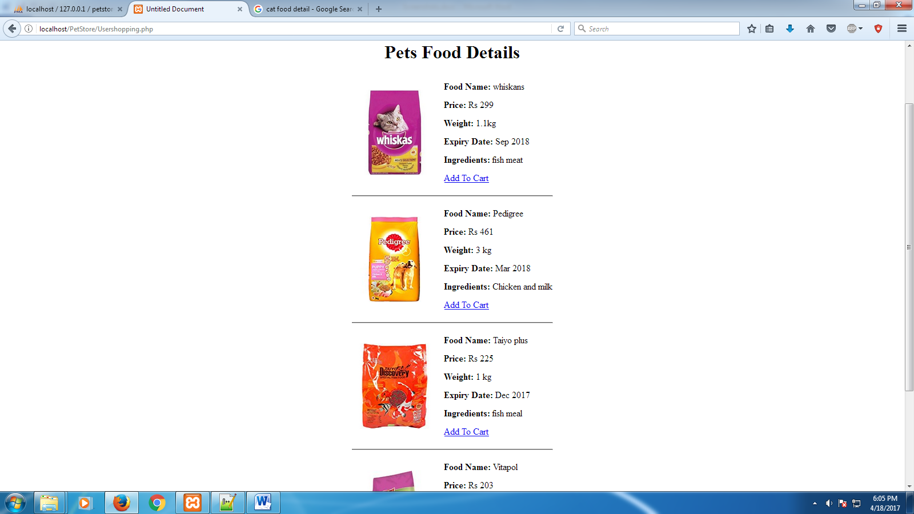

**Add to cart**

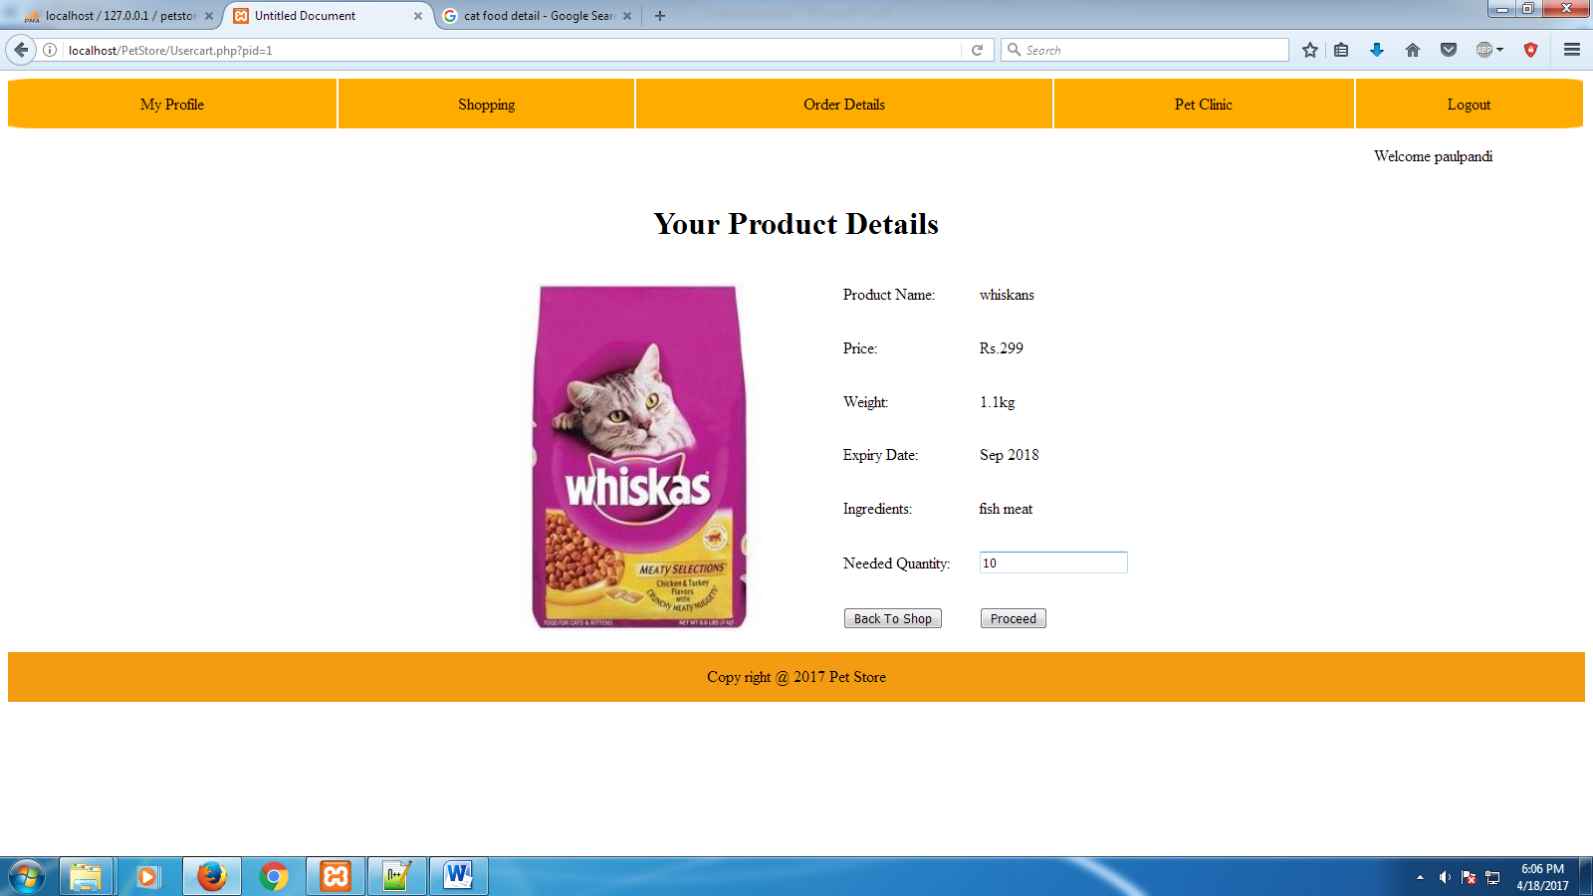

**Order**

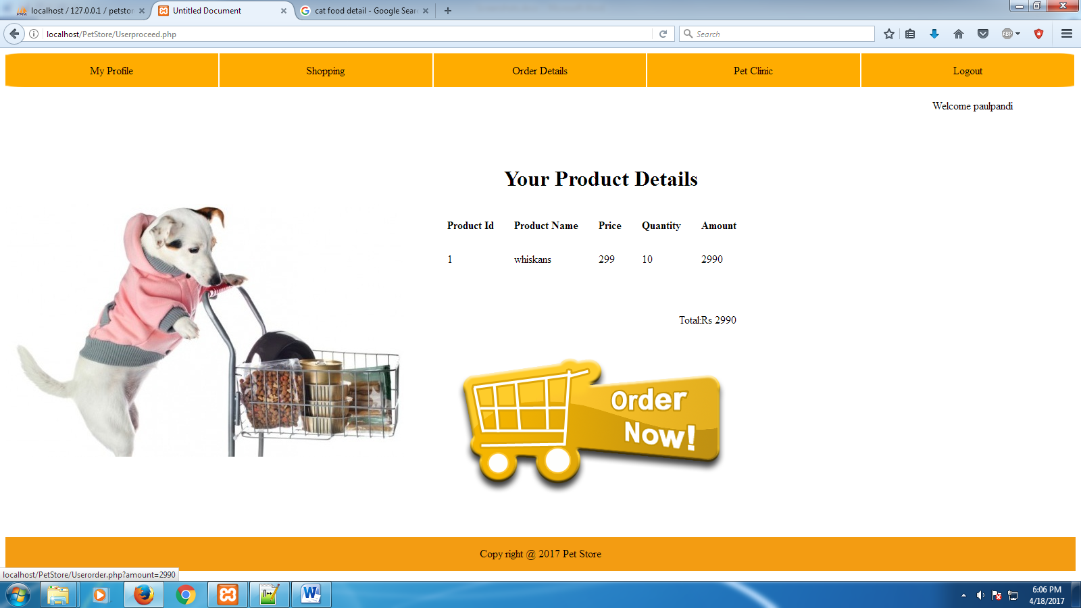

**Shipping**

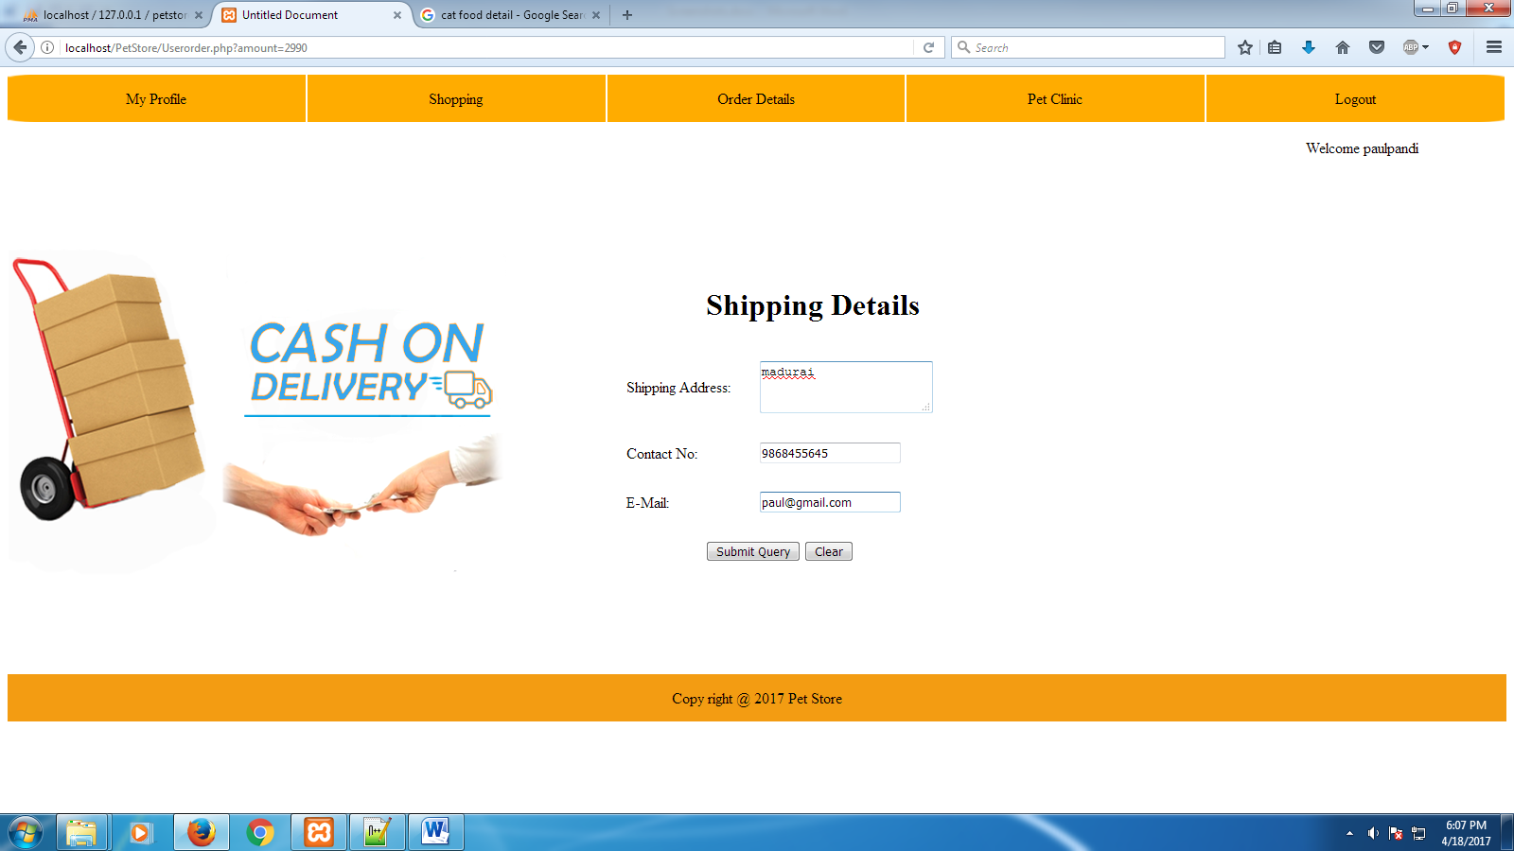

**Order details**

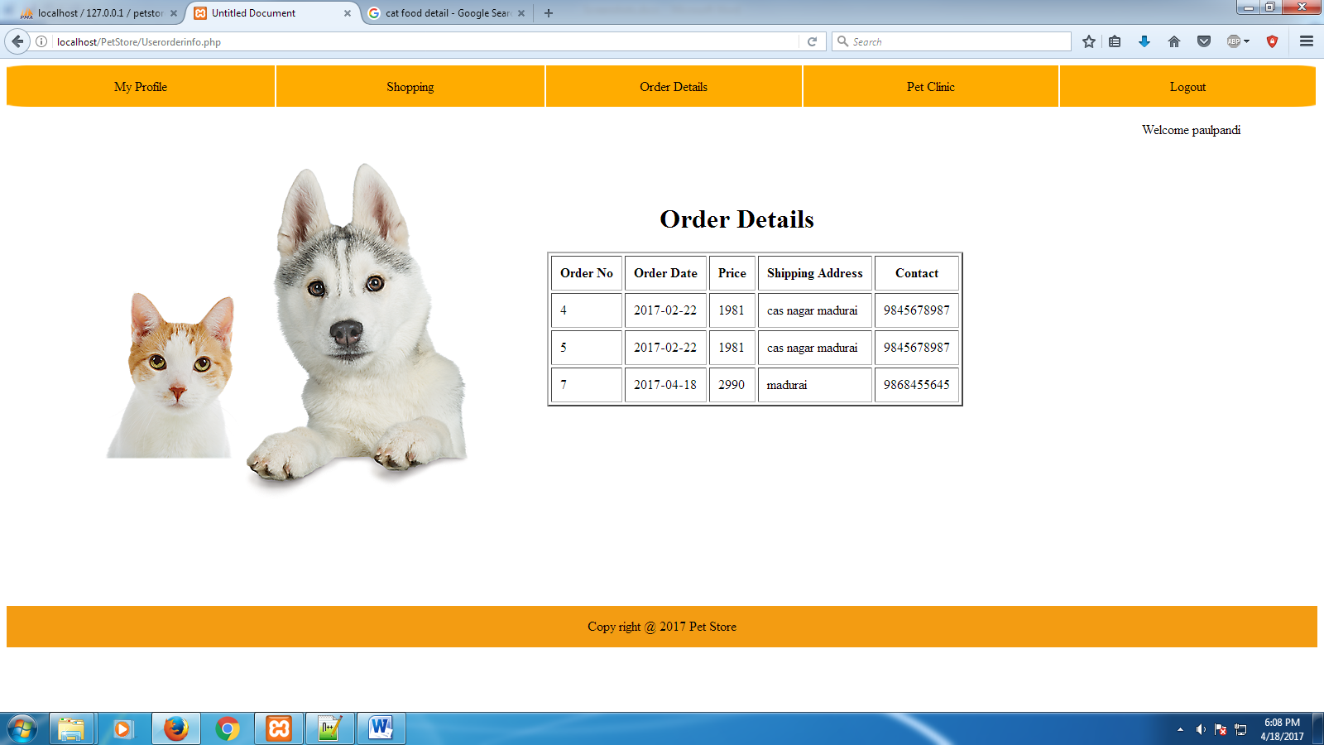

**10.2 SOURCE CODE**

<!DOCTYPE html PUBLIC "-//W3C//DTD XHTML 1.0 Transitional//EN" "http://www.w3.org/TR/xhtml1/DTD/xhtml1-transitional.dtd">

<html xmlns="http://www.w3.org/1999/xhtml">

<head>

<meta http-equiv="Content-Type" content="text/html; charset=utf-8" />

<title>Untitled Document</title>

<style>

.demo

{

background-image:url(images/bg-search-form.gif);

background-size:100%100%;

}

.ss

{

text-decoration:none;

text-align:center;

color:black;

}

.ss:hover

{

color:white;

}

.aa

{

border-right:2px solid white;

text-align:center;

}

div

{

text-align:justify;

line-height:25px;

}

</style>

</head>

<body>

<?php

include("DB.php");

session_start();

?>

<?php

?>

<form name="f" method="post" action="" onSubmit="mysubmit();">

<table cellspacing="0" width="100%">

<tr class="demo" height="50px">

<td class="aa" ><a href="Userprofile.php" class="ss">My Profile</a></td>

<td class="aa"><a href="Usershopping.php" class="ss">Shopping</a></td>

<td class="aa"><a href="Userorderinfo.php" class="ss">Order Details</a></td>

<td class="aa"><a href="Petclinic.php" class="ss">Pet Clinic</a></td>

<td class="aa"><a href="Home.php" class="ss">Logout</a></td>

</tr>

<tr>

<td colspan="5">

<p align="right">

<?php

if(isset($_SESSION['user']))

{

echo "Welcome ".$_SESSION['user'];

}

?>

&nbsp;&nbsp;&nbsp;&nbsp;&nbsp;&nbsp;&nbsp;&nbsp;&nbsp;&nbsp;&nbsp;&nbsp;&nbsp;&nbsp;&nbsp;&nbsp;&nbsp;&nbsp;&nbsp;&nbsp;&nbsp;&nbsp;&nbsp;

</p>

</td>

</tr>

<tr>

<td colspan="5" align="center">

<p align="center"><h1>Pets Food Details</h1></p>

<?php

if(!$con)

{

echo "Connectio error ".mysqli_connect_error();

}

else

{

$q="select *from fooddata";

$result=mysqli_query($con,$q);

echo "<table align='center' cellspacing='10'>";

//echo "<tr><td>";

echo mysqli_error($con);

while($r=mysqli_fetch_assoc($result))

{

$pic=$r['photo'];

$id=$r['fid'];

echo "<tr><td rowspan='6'><img src='food/$pic' width='150' height='150'>";

echo "</td><td><b>Food Name:</b> ".$r['foodname']."</td></tr>";

echo "<tr>";

echo "<td><b>Price:</b> Rs ".$r['price']."</td></tr>";

echo "<tr>";

echo "<td><b>Weight:</b> ".$r['weight']."</td></tr>";

echo "<tr>";

echo "<td><b>Expiry Date:</b> ".$r['expirydate']."</td></tr>";

echo "<tr>";

echo "<td><b>Ingredients:</b> ".$r['ingredients']."</td></tr>";

echo "<tr>";

echo "<td><a href='Usercart.php?pid=$id'>Add To Cart</a></td></tr>";

echo "<tr><td colspan='2'><hr></td></tr>";

// echo "</table>";

}

echo "</table>";

}

?>

</td>

</tr>

<tr bgcolor="#f39c12" height="50">

<td colspan="5" align="center">

Copy right @ 2017 Pet Store

</td>

</tr>

</table>

</td>

</tr>

</table>

</form>

</body>

</html>